1. **Percobaan File Babel 1**

**Code:**

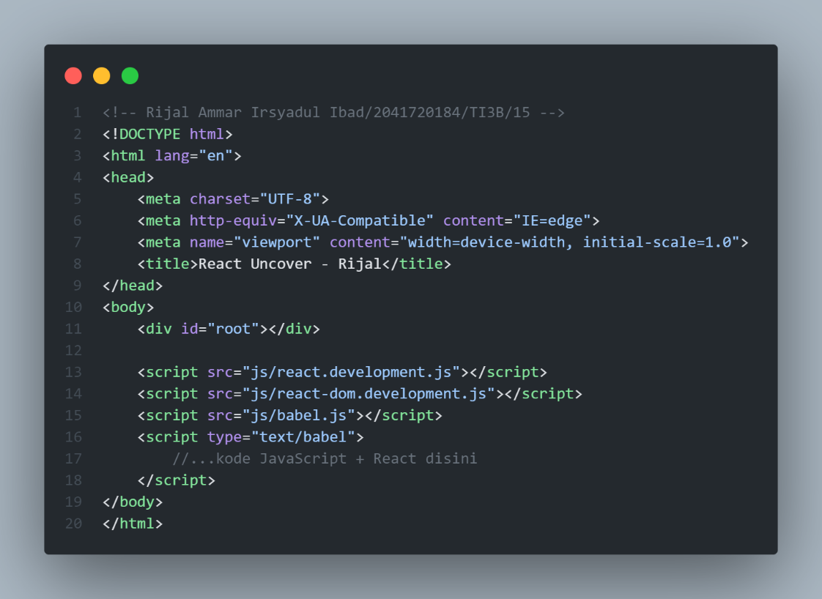

**Hasil:**

1. **Percobaan File Babel 2**

**Code:**

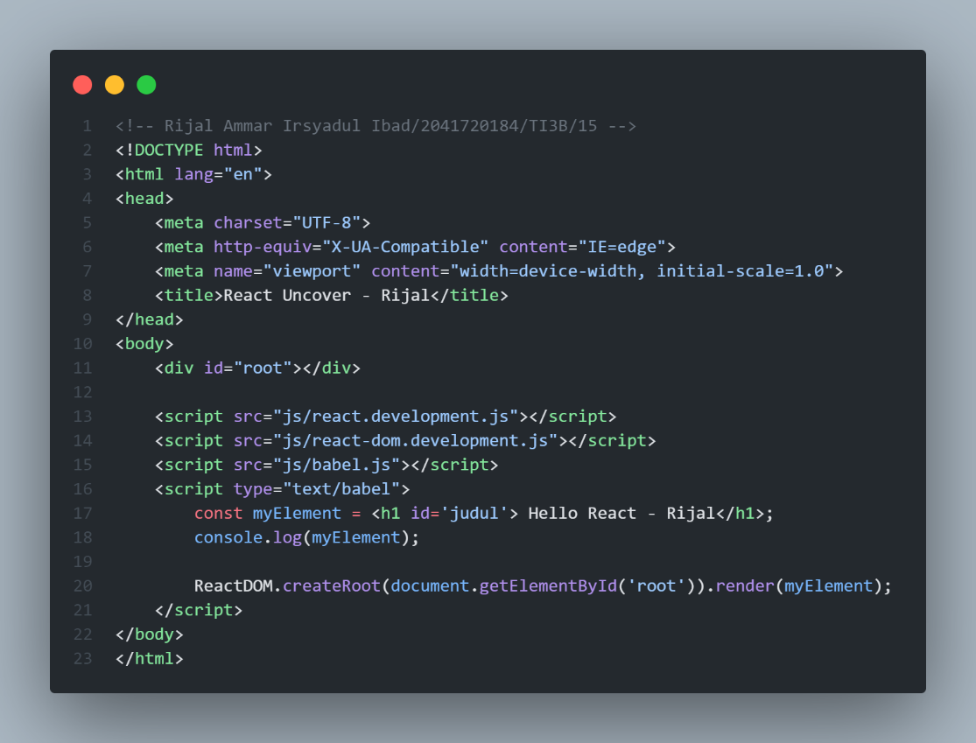

**Hasil:**

1. **Percobaan File Babel 3**

**Code:**

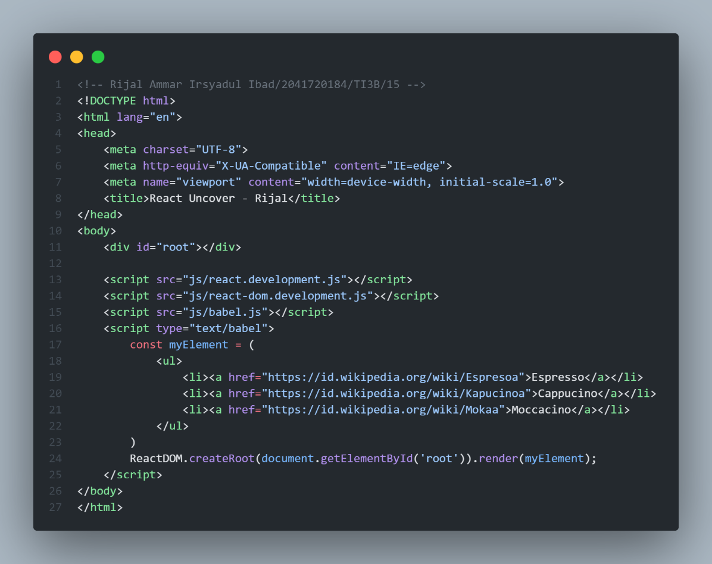

**Hasil:**

**Tampilan Awal:**

**Ketika Link Di Klik:**

1. **Percobaan JSX 1**

**Code:**

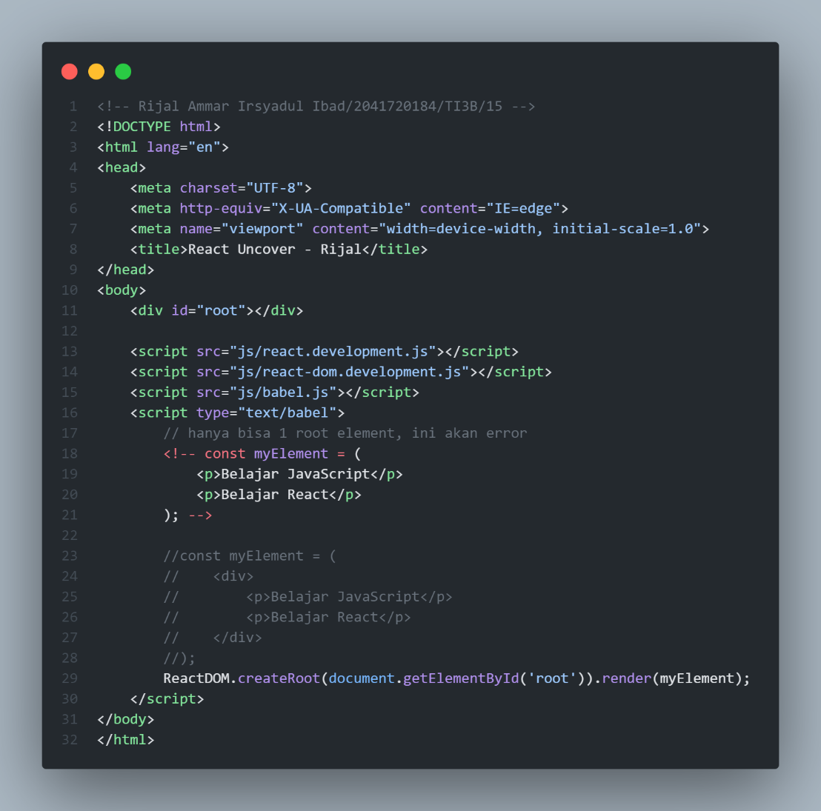

**Hasil:**

1. **Percobaan JSX 2**

**Code:**

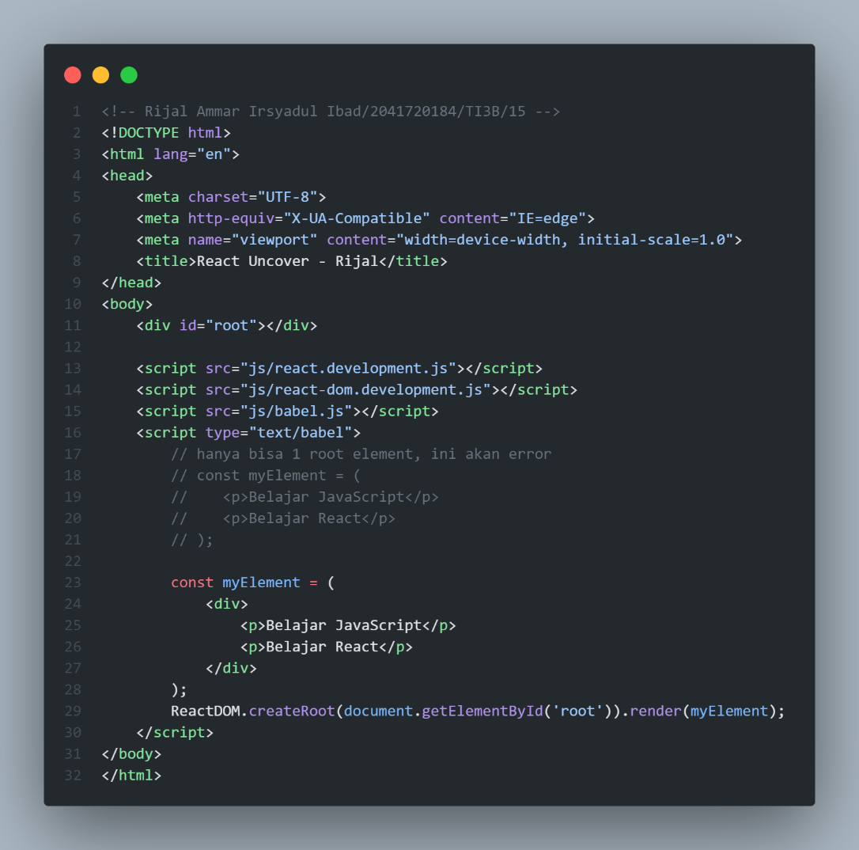

**Hasil:**

1. **Percobaan JSX 3**

**Code:**

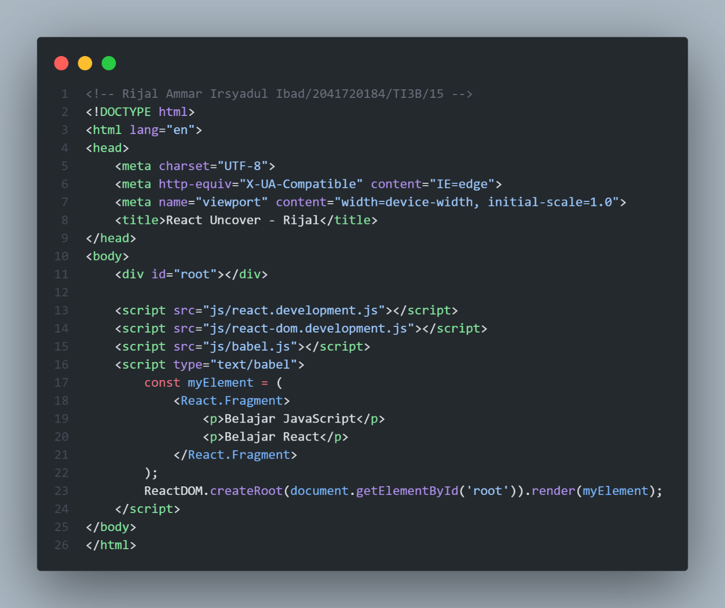

**Hasil:**

1. **Percobaan JSX 4**

**Code:**

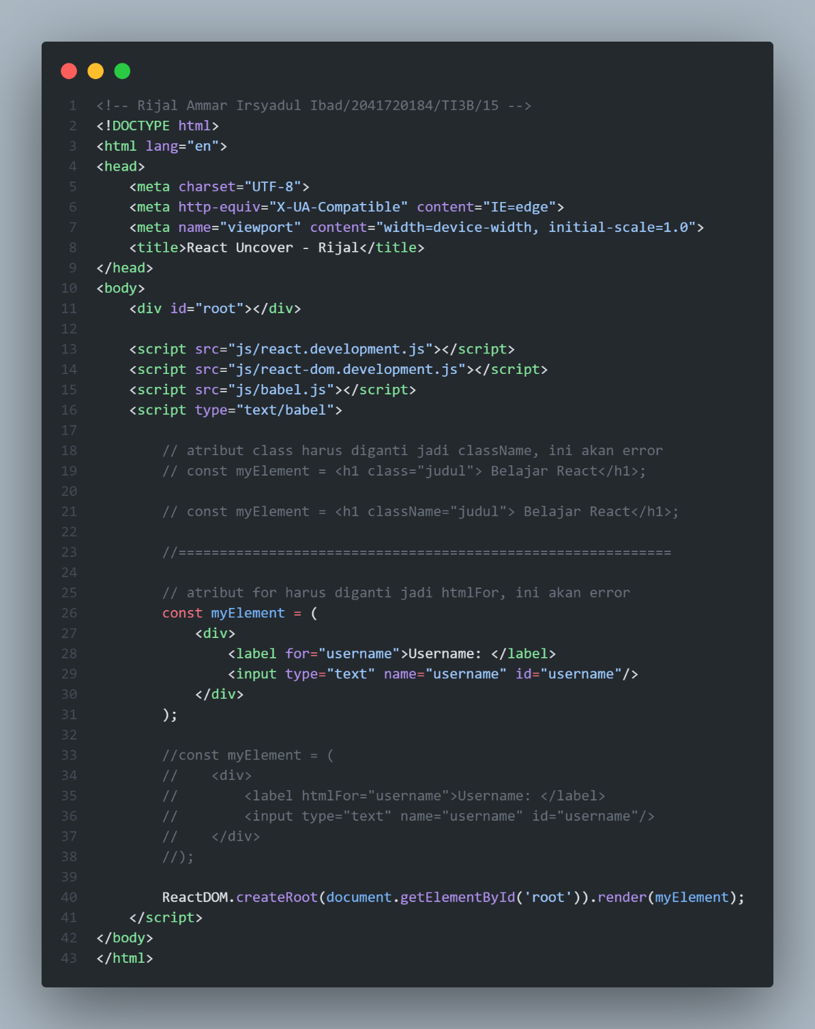

**Hasil:**

1. **Percobaan Statement JSX**

**Code:**

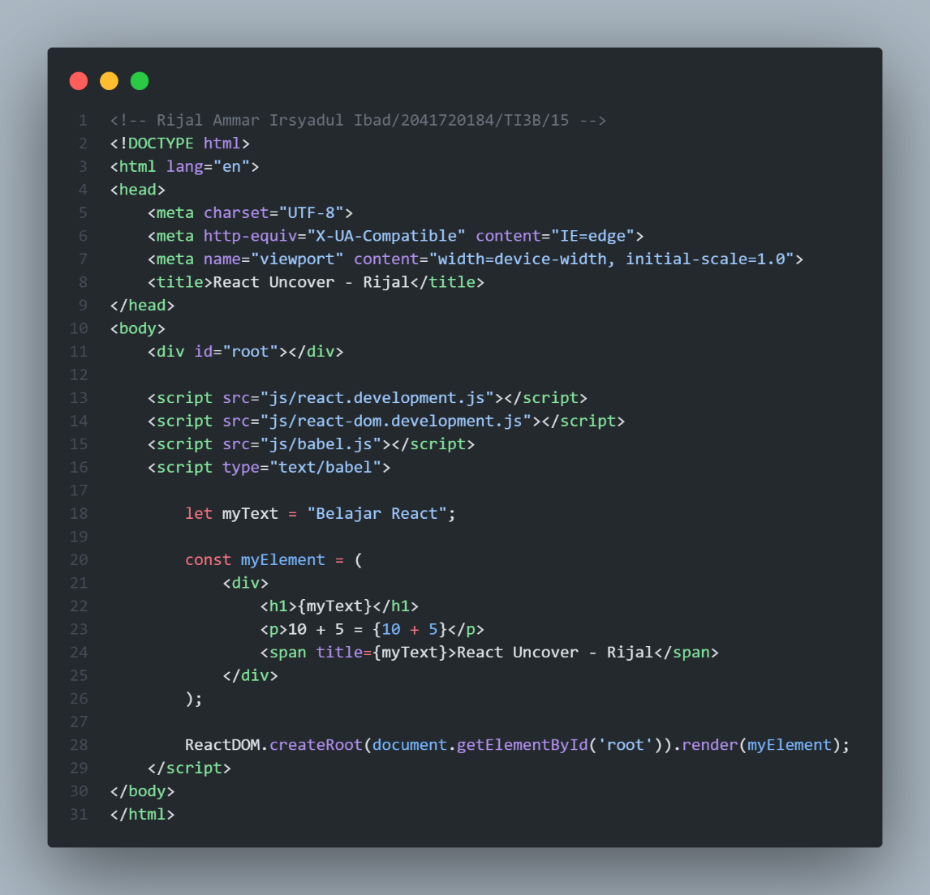

**Hasil:**

1. **Percobaan Atribut Style**

**Code**

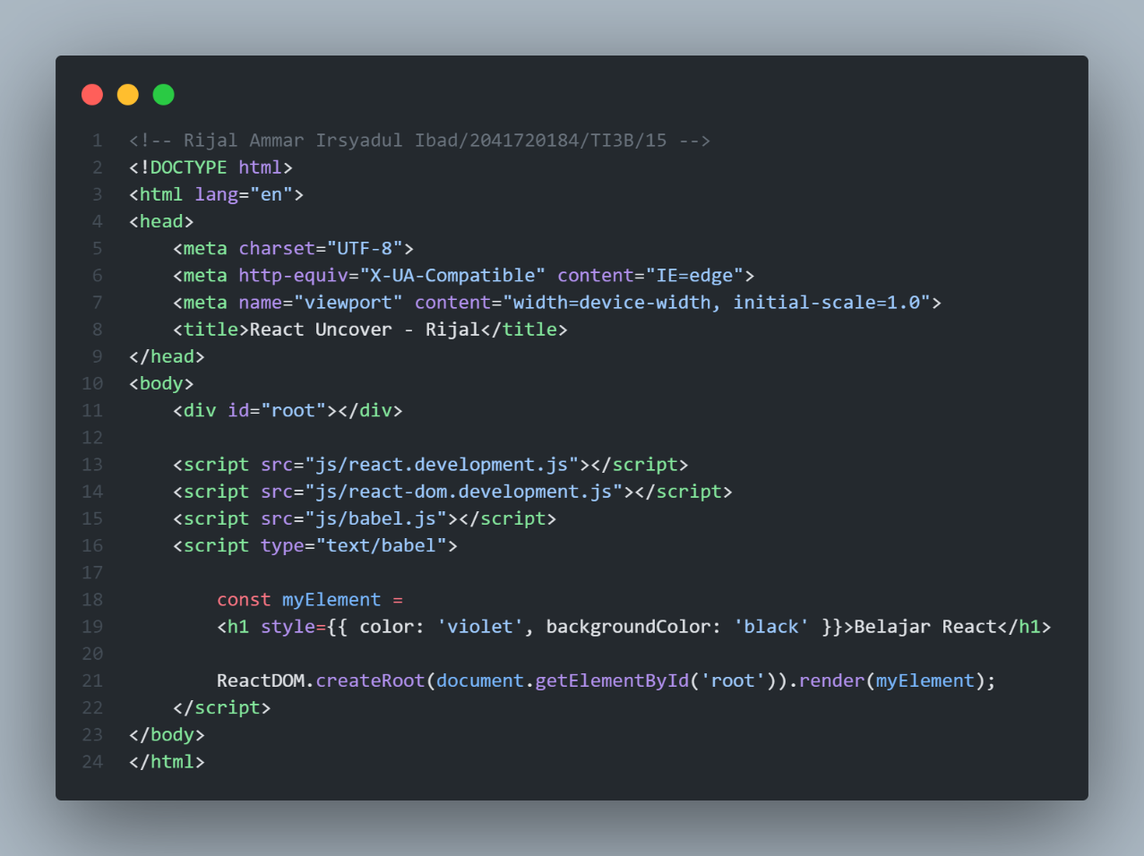

**Hasil:**

1. **Percobaan Percabangan Kondisi 1**

**Code:**

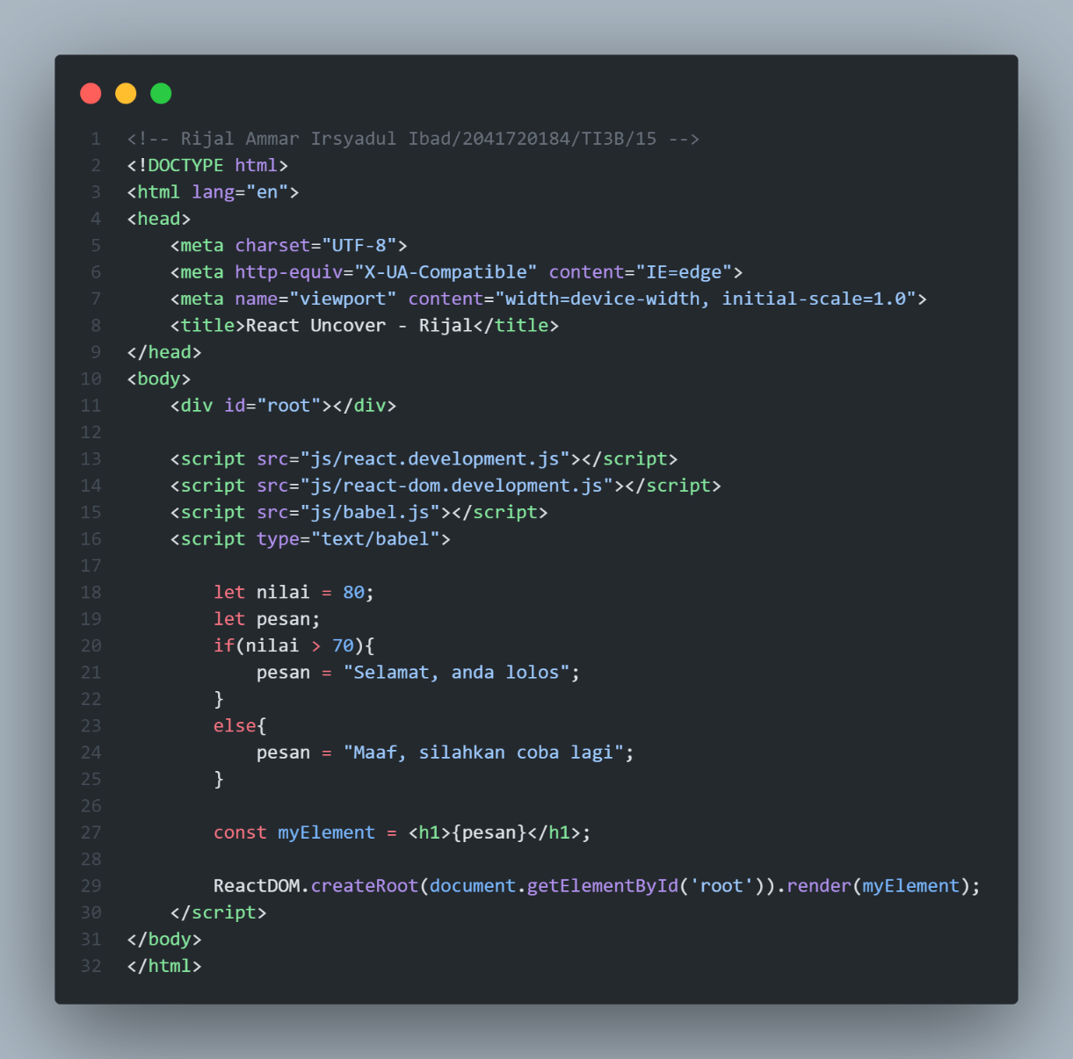

**Hasil:**

1. **Percobaan Percabangan Kondisi 2**

**Code:**

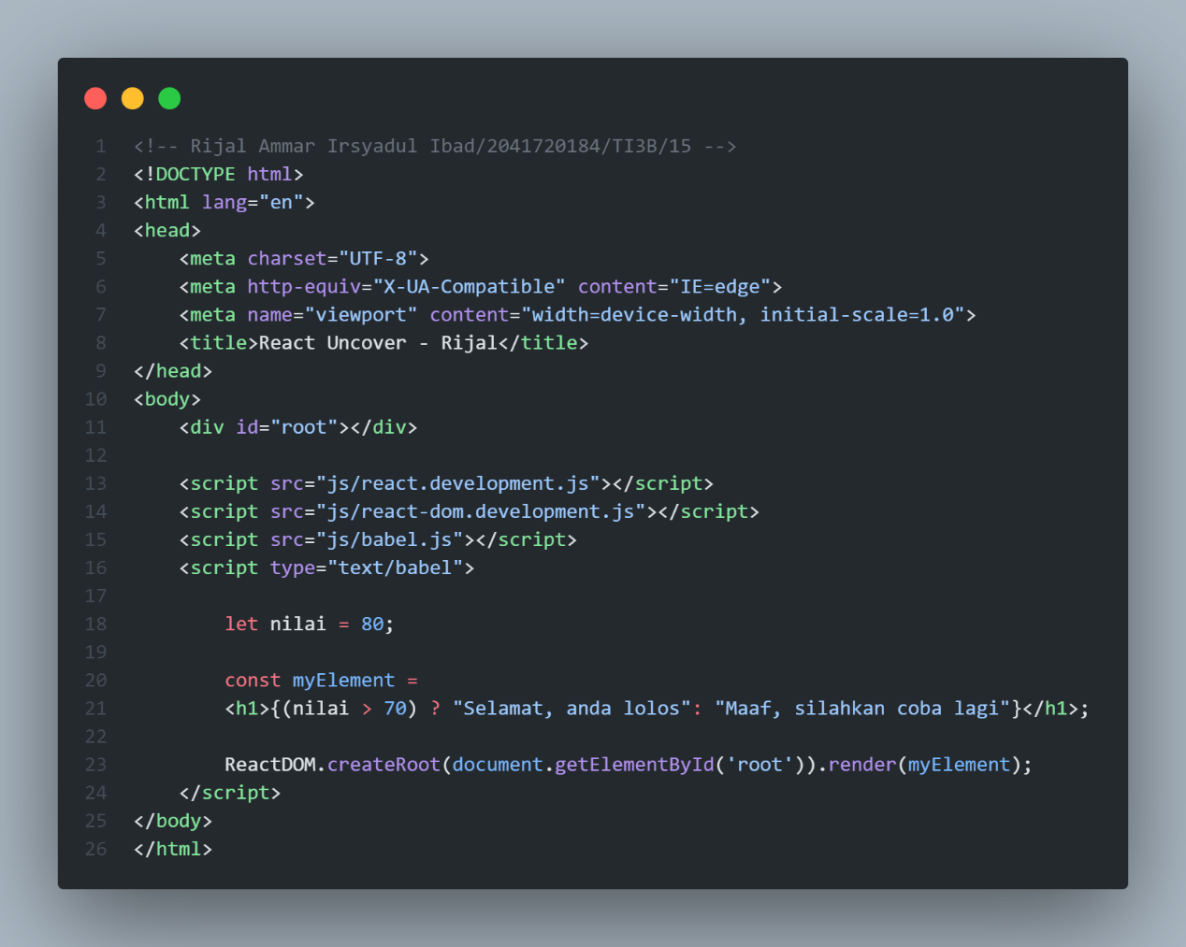

**Hasil:**

1. **Percobaan Percabangan Kondisi 3**

**Code:**

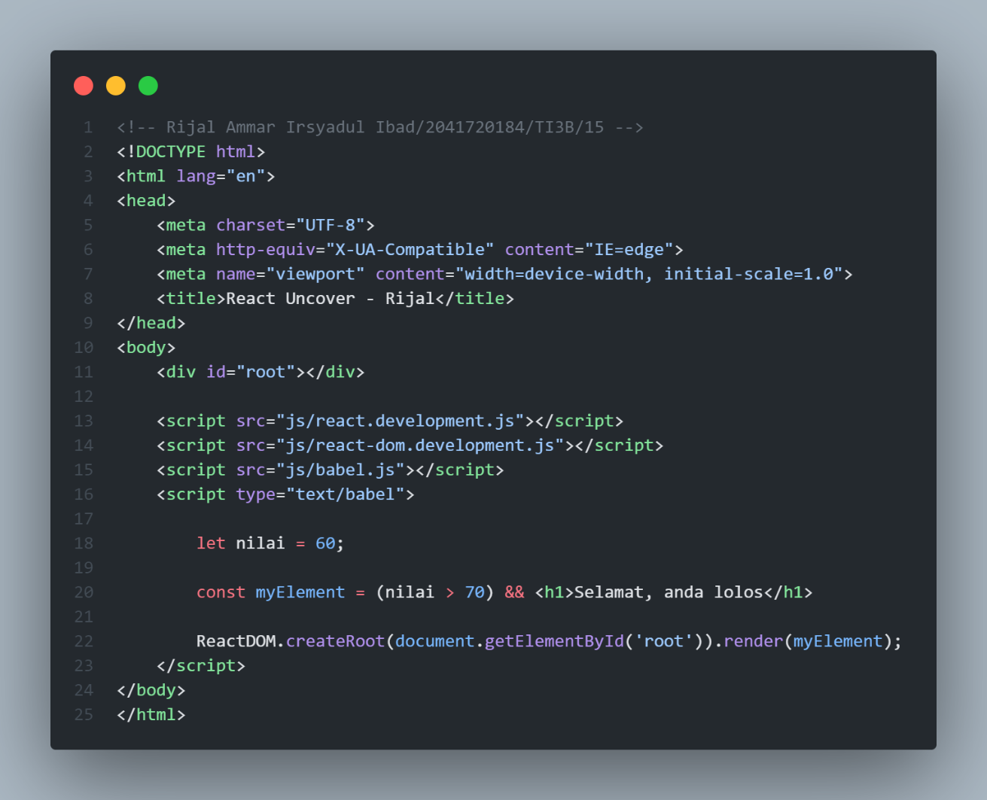

**Hasil:**

1. **Percobaan Percabangan Kondis 4**

**Code:**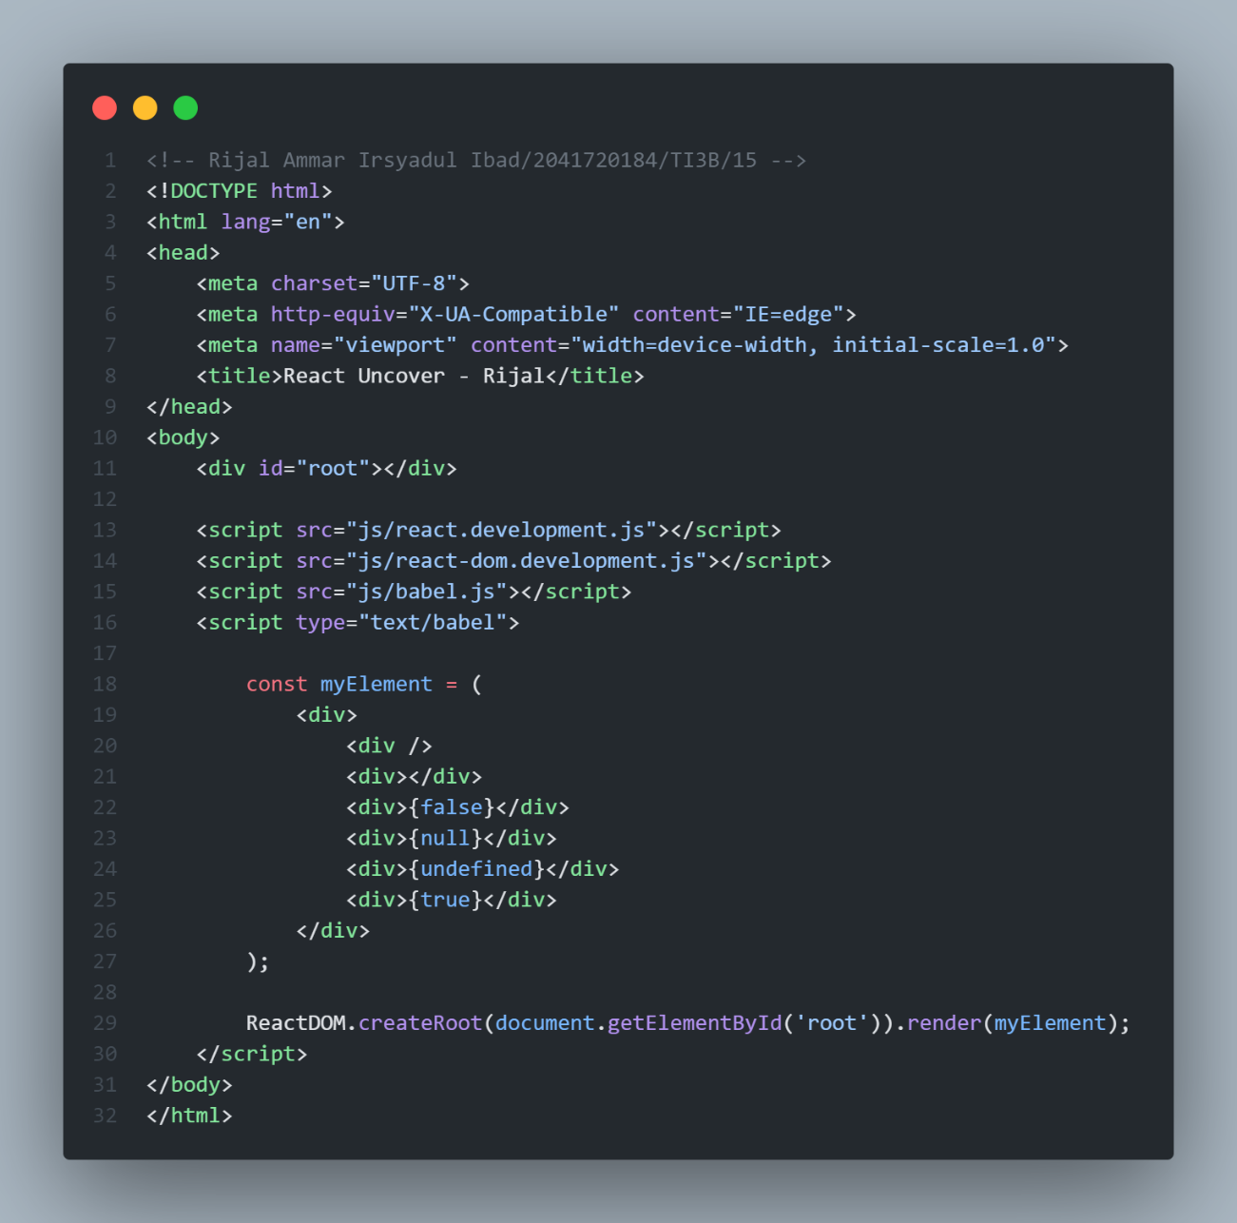

**Hasil:**

1. **Percobaan Array Processing 1**

**Code:**

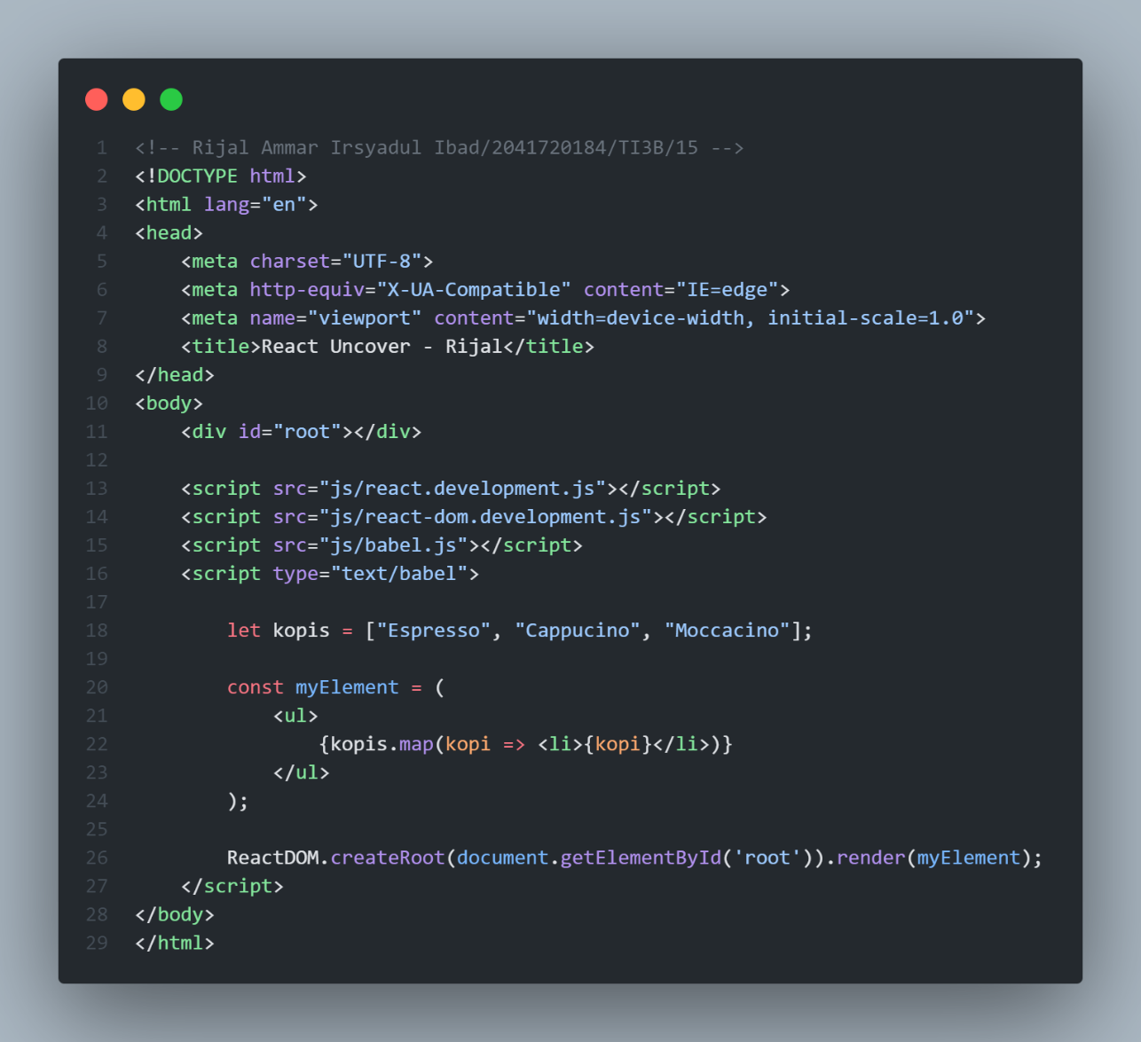

**Hasil:**

1. **Percobaan Array Processing 2**

**Code:**

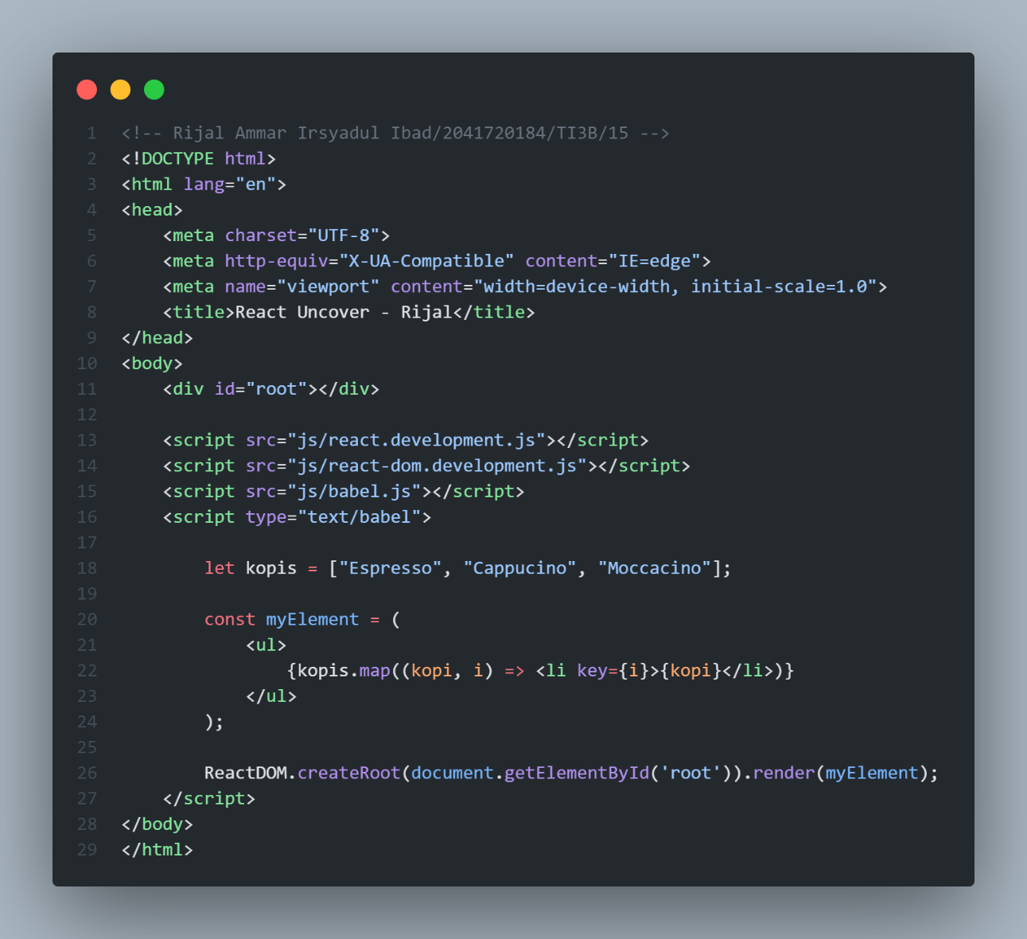

**Hasil:**

1. **Percobaan Array Processing 3**

**Code:**

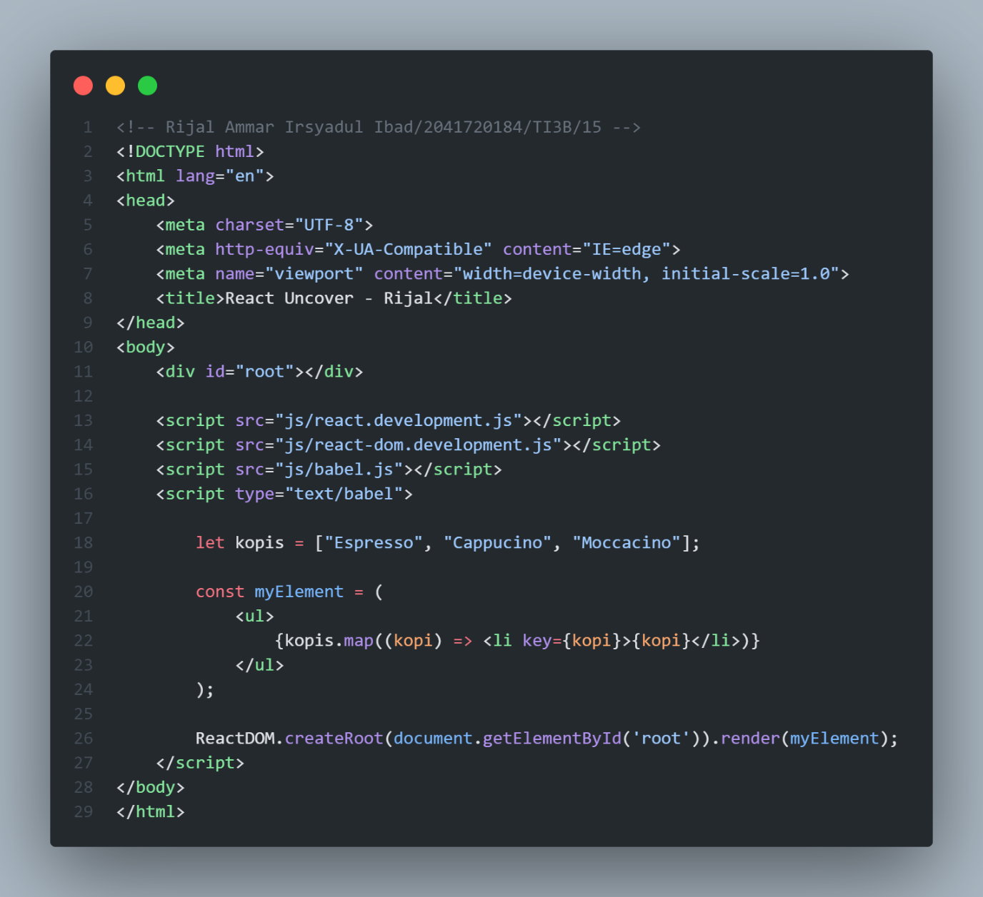

**Hasil:**

1. **Percobaan JavaScript Event 1**

**Code:**

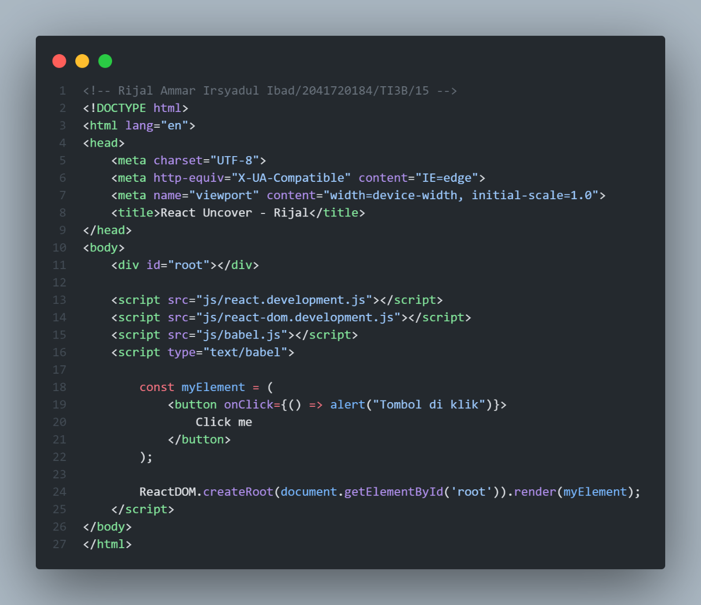

**Hasil:**

1. **Percobaan JavaScript Event 2**

**Code:**

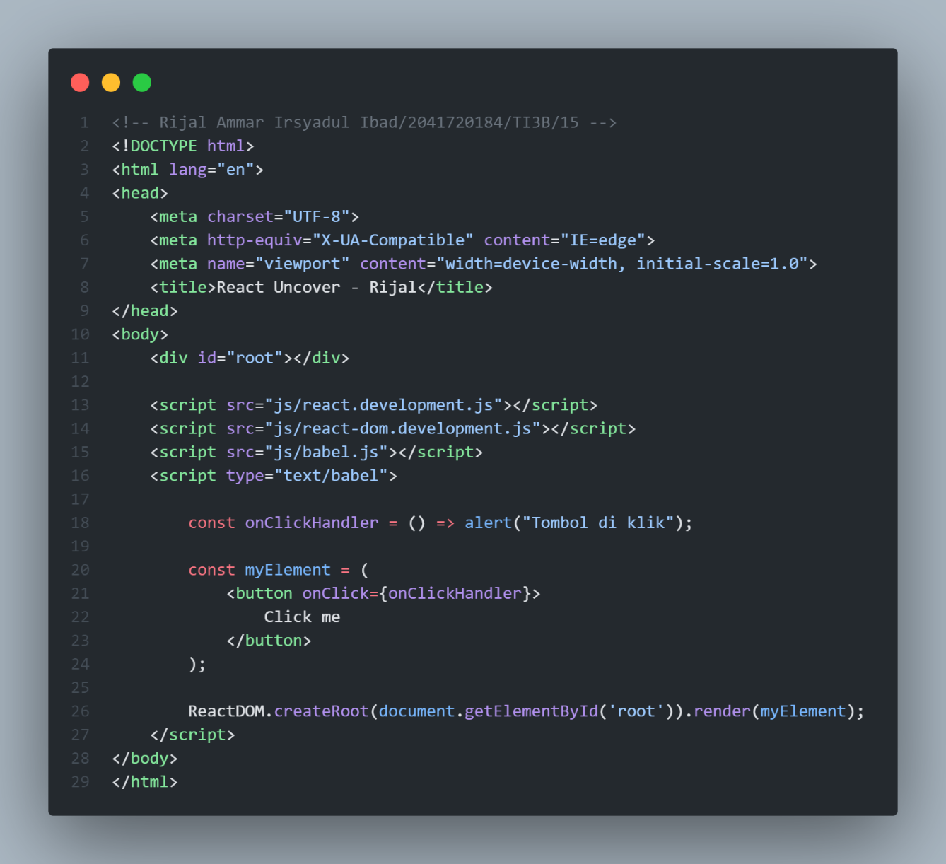

**Hasil:**

